Open “PathMaker” window from menu

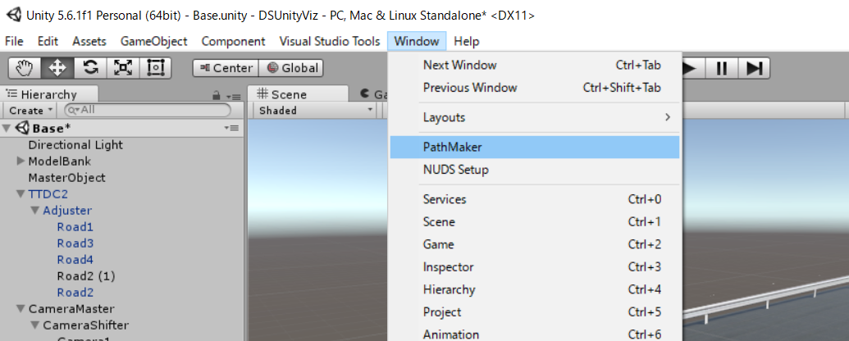

[Set marker mesh]
expand [using mesh]
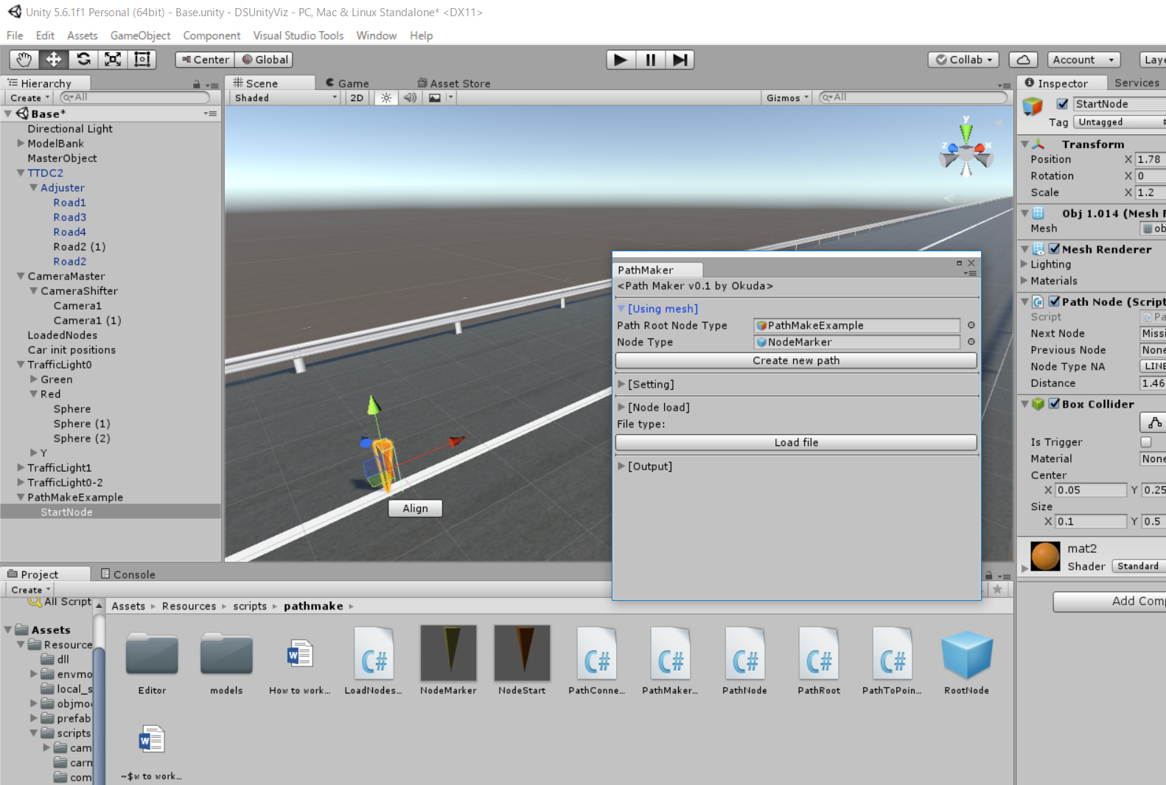

“Path root Node Type” => scripts/pathmake/NodeStart
“Node Type” => scripts/pathmake/NodeMarker

Click “Create new path”
Then , you can see “new Path**” at the origin.
When you select root node (created node),
“Path Root Node Type” in Pathmaker window starts to indicate created root node.

[Create course]

Expand [setting] tab.
You can toggle “enable create” to start “node create mode.”
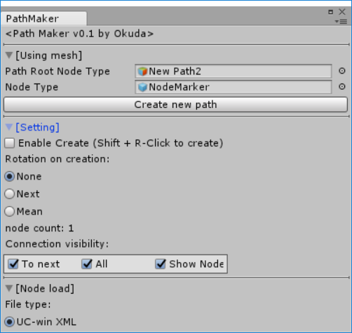
If you see you cannot toggle the “Enable Create” button as shown in below,
Node types in [Usingmesh] is not set appropriately.
Please go back to setup section(using mesh) in that case.
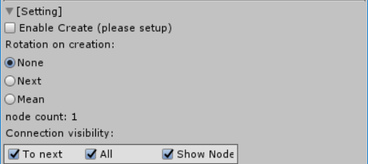

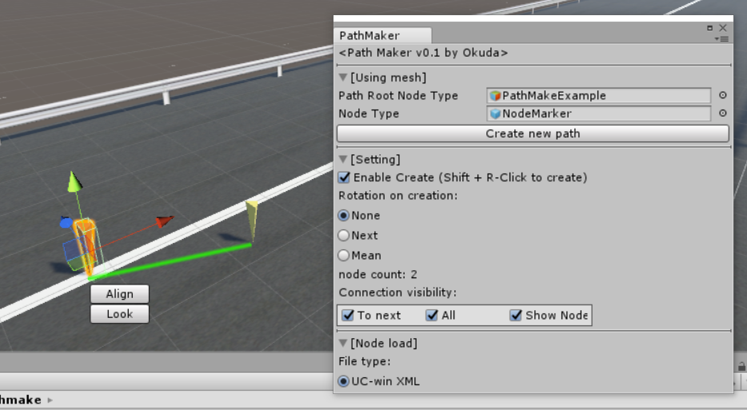
If you successfully checked the “Enable create” button, please select the last node which is created in the path.
Then, you can create new node by right clicking with shift key.
Note that the surface to create node on must have collider(mesh or box collider).
This right click find the intersection point with the ground using collider.

If you check “Next” in “rotation on creation” (yellow circle), the previous node see the created node. “None” does not change the direction of previous node.
If “Mean” is selected, the created node will see the average of tangential angle considering its previous node and created node.

“Rotation on creation”
New node
New node
New node
pre node(rotated)
pre node(rotated)
None Next Mean

When you toggle the connection visibility, link visualization will be changed.

[output]

Created path can be output to CSV file.
- Input file name to text box.
- Put the interpolation distance if you need and check the box.
- Push output!
- You can find output file in project directory.

